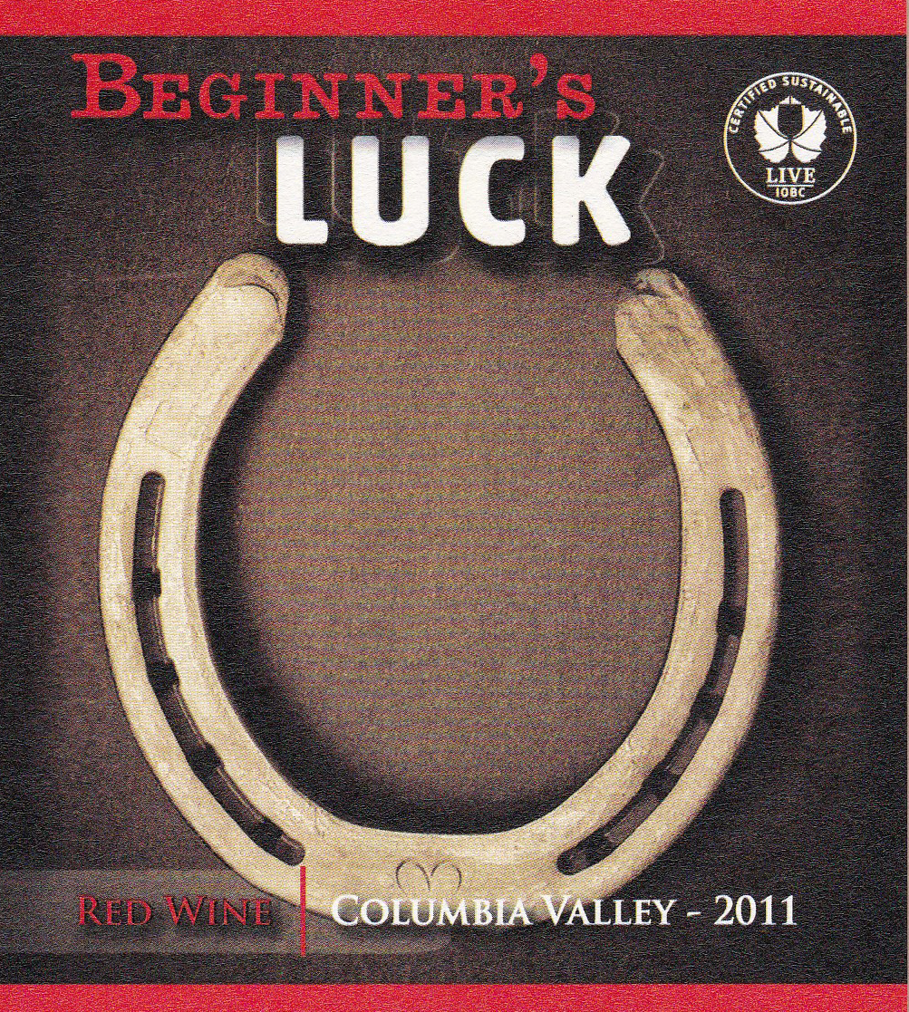
BEGINNER’S LUCK
RED WINE
2011

TASTING NOTES:

Vanilla, caramel, dark cherry, strawberry, toasted oak and bell pepper aromas. The palate is very soft with just enough acidity to allow this lighter styled red to pair well with dishes such as eggplant parmesan, chicken cacciatore, or baked ham.

GRAPE SOURCE:

100% Columbia Valley

WINEMAKING NOTES:

Varietal Breakdown: 30.7% Merlot, 20.1% Syrah, 15.8% Petit Verdot, 12.7% Cabernet Franc, 10.6% Malbec, 5.9% Cabernet Sauvignon, 4.2% Sangiovese.

ANALYSIS:

- T/A - 0.56 grams/100ml

- pH - 3.65

- Alcohol: 13.5% by volume

- Bottled: May, 2014

